Deep Learning and Music Recommendation: Modeling My Past, or Helping Me Discover?

Matthew Naughton
Northeastern University
ALY 3510: AI Foundations: An Interdisciplinary Approach
Professor Vladimir Shapiro
Fall 2026

Deep Learning and Music Recommendation: Modeling My Past, or Helping Me Discover?
Introduction
Music recommendation looks like an ideal job for a neural network. A streaming service knows what I play, skip, save, replay, and group into playlists, and in theory all of that behavior should let a system learn my taste and point me toward music I will like. My experience with Spotify has been more mixed, and the gap between that promise and the result is what I want to examine. Using the course video on neural networks as a starting point, I trace how the basic idea scales into music recommendation, where it works, and where it runs into a harder question: what should the system actually be learning?
Key Takeaways From the Video
The video builds the concept around a movie-recommendation neuron. Ratings from three critics enter as inputs, each carrying a weight, and the neuron combines them into a single predicted rating. After I rate the movie myself, the weights adjust—critics who tend to agree with me gain influence, and the ones who do not lose it. Nobody writes a rule saying one critic should count more than another; the system learns that relationship from feedback (CodeAI, 2020). The deeper point is what happens when many of these simple units are stacked into layers, each layer's output feeding the next. That layering is what turns a weighted average into something that can recognize complex patterns, and it is the step from a single neuron to deep learning.
Two Ways to Learn Taste: Behavior vs. the Music Itself
Applied to music, that learning can happen in two very different ways. Spotify leans heavily on collaborative filtering—inferring my taste from my behavior and from patterns across millions of other listeners, on the theory that people who act like me are a good guide to what I will want next. Because its algorithms are proprietary, the exact mechanics can only be inferred, but the general approach is well understood: streams, skips, saves, and playlist choices become the inputs, and the system balances exploiting what it already knows about me against exploring new material (Maheshwari, 2023). Pandora takes the opposite route. Its Music Genome Project has trained musicologists tag each song with hundreds of musical attributes, so recommendations are driven by characteristics of the music itself rather than by what other people happened to click (Pandora, n.d.). One approach models me; the other models the song. The movie-critic example in the video is really a tiny version of the first—weighting other people's opinions—which may be part of why collaborative systems are so good at predicting the familiar and so uneven at surfacing something genuinely new. The overall flow of a behavior-based recommender, including the feedback loop it creates, is shown in Figure 1.
Figure 1
A Behavior-Based (Collaborative-Filtering) Music Recommender
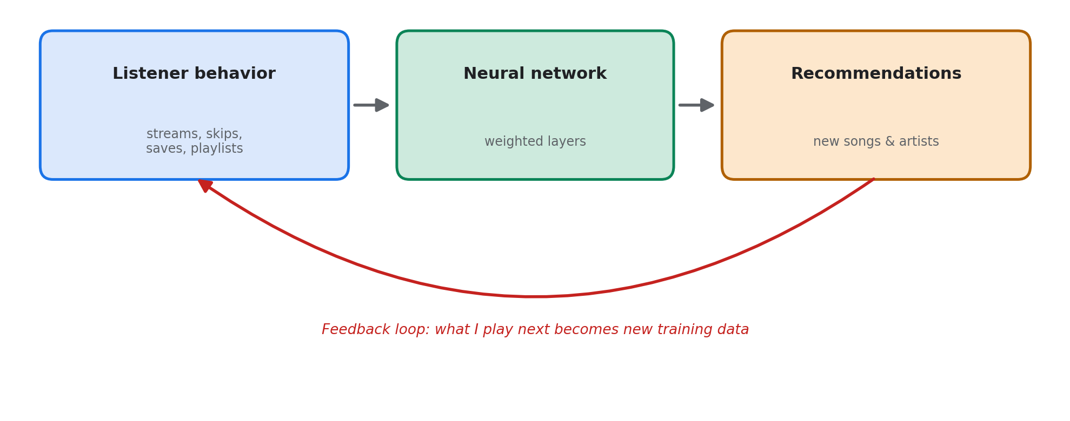
Note. A behavior-based recommender learns from listener activity, predicts recommendations, and treats the listener's response as new training data. That returning arrow is the feedback loop discussed under “Downsides,” which can gradually narrow what the system shows.
What Surprised Me Most
The part that caught me off guard is that the network never has to know why I like something. It only needs examples and feedback, and it adjusts the weights accordingly. That matters more than it sounds, because musical taste resists explanation. I can say I like the Grateful Dead, The Band, the Rolling Stones, and Van Morrison, but that does not mean I want everything filed under those genres, and even within one band's catalog there are songs I love and songs I skip. Genre and artist similarity do not really describe what I am after.
My clearest example came from outside Spotify entirely. I found an Australian group, The Bures Band, through a Reddit thread, liked them enough to build a playlist of their three albums, and let it run into autoplay. The recommendations that followed were the best I can remember getting—mostly artists and songs I did not know but enjoyed, and when a familiar artist appeared it was usually a song I had never heard. Notably, it did not just recycle tracks from playlists I had already curated. I cannot know why autoplay behaved differently, since the algorithm is proprietary, but my suspicion is that one tightly focused playlist gave the system a cleaner signal about what I wanted in that moment than my years of accumulated history ever had. My library represents choices made for different reasons—music for driving, for working, for nostalgia—and averaged together, all of it is legitimately me without describing what I want to discover next. More data did not mean better personalization; a small amount of relevant context did.
The Most Impactful Use of Neural Networks
Music is a low-stakes place to watch this play out, which is part of why it makes a useful example. The most impactful uses of neural networks are probably the ones the video gestures at near the end: detecting disease, predicting floods and wildfires, and supporting conservation (CodeAI, 2020). The common thread with recommendation is pattern recognition at a scale no person could monitor—but the stakes could not be more different. A missed recommendation costs me a good song; a missed early signal of a wildfire or a tumor costs far more. If I had to name the single most impactful use, it would be that class of problems: pointing the same pattern-finding ability at a critical signal and surfacing it early enough for a person to act. Music recommendation is the same machinery aimed at a much gentler target.
Societal and Business Impact
For a streaming business, recommendation is about engagement—keeping listeners on the platform. The more consequential impact is on discovery and on who gets heard. A recommender can connect a listener with an artist they would never have found through radio or their existing social circle, which means these systems increasingly shape which musicians reach an audience at all. My own path to The Bures Band shows both sides: a human community made the introduction, and once Spotify had that starting point, its system carried the discovery further. Spotify now frames discovery, not just prediction, as the hard problem it is working to solve (Spotify Research, 2026)—a meaningful shift, because optimizing for what someone will click is not the same as helping them find something worth hearing.
Downsides and How to Overcome Them
The biggest downside I see is the feedback loop. If I listen to something because the system suggested it, that listen becomes new evidence that I like it, and the system grows more confident in a profile it helped create. Taken far enough, the better a recommender gets at predicting me, the more predictable my listening becomes—similarity crowds out serendipity. There is also the familiar data-quality problem: a model trained on signals that do not reflect what I actually want will produce confident recommendations that still miss.
The fix I would want is control over that tradeoff. A listener should be able to tell the system whether a session is about comfort or discovery, and how far outside their established taste to reach. That turns the network into a tool I steer rather than a mirror that keeps showing me back to myself. Spotify's own research points roughly in that direction (Spotify Research, 2026), but I would want it as an explicit control—not something I have to coax out of the system by hand-building a narrow playlist.
Conclusion
The video makes the mechanics intuitive: weight the inputs, compare the output to reality, adjust, and repeat. Music shows both why that works and where it gets complicated. Learning what I already like is the easy half; the harder and more valuable half is knowing when to reinforce that taste and when to push against it. My best recommendation was not the song the system could most confidently predict—it was the one that sat between familiar and unfamiliar. For music discovery, and arguably for recommendation in general, that second problem is the one worth solving.

References
CodeAI. (2020, December 1). How neural networks work [Video]. YouTube. https://www.youtube.com/watch?v=JrXazCEACVo
Maheshwari, C. (2023). Music recommendation on Spotify using deep learning. arXiv. https://doi.org/10.48550/arXiv.2312.10079
Pandora. (n.d.). Music Genome Project. Retrieved September 16, 2026, from https://www.pandora.com/about/mgp
Spotify Research. (2026). From models to products: LLMs for recommendation at Spotify scale. https://research.atspotify.com/2026/8/from-models-to-products-llms-for-recommendation-at-spotify-scale

